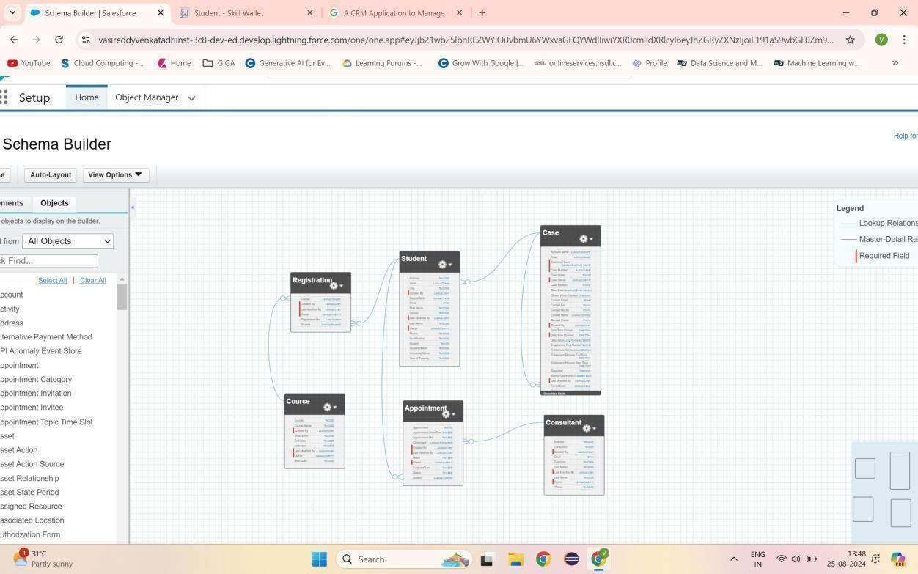

**Fig1.1 Lookup relationship among Objects**

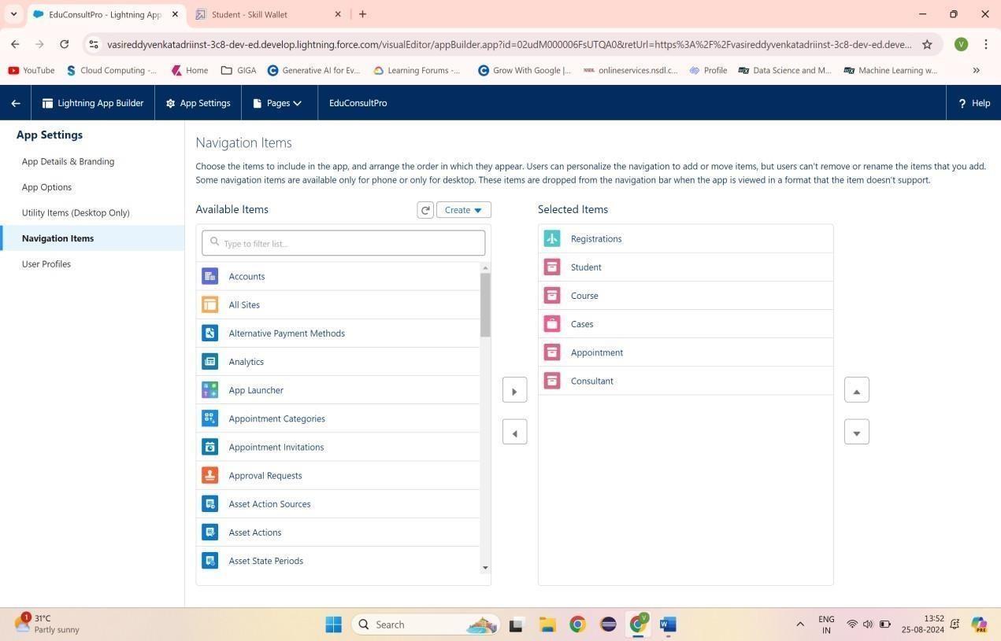

## Fig1.2 Adding items to EduConsultPro

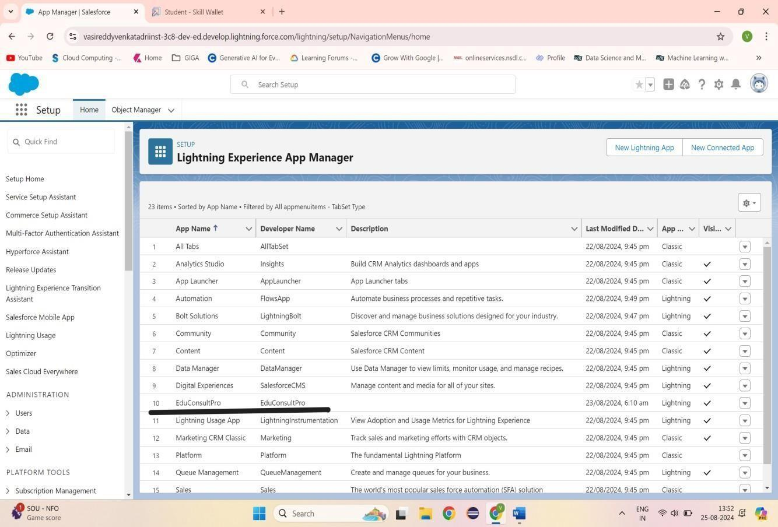

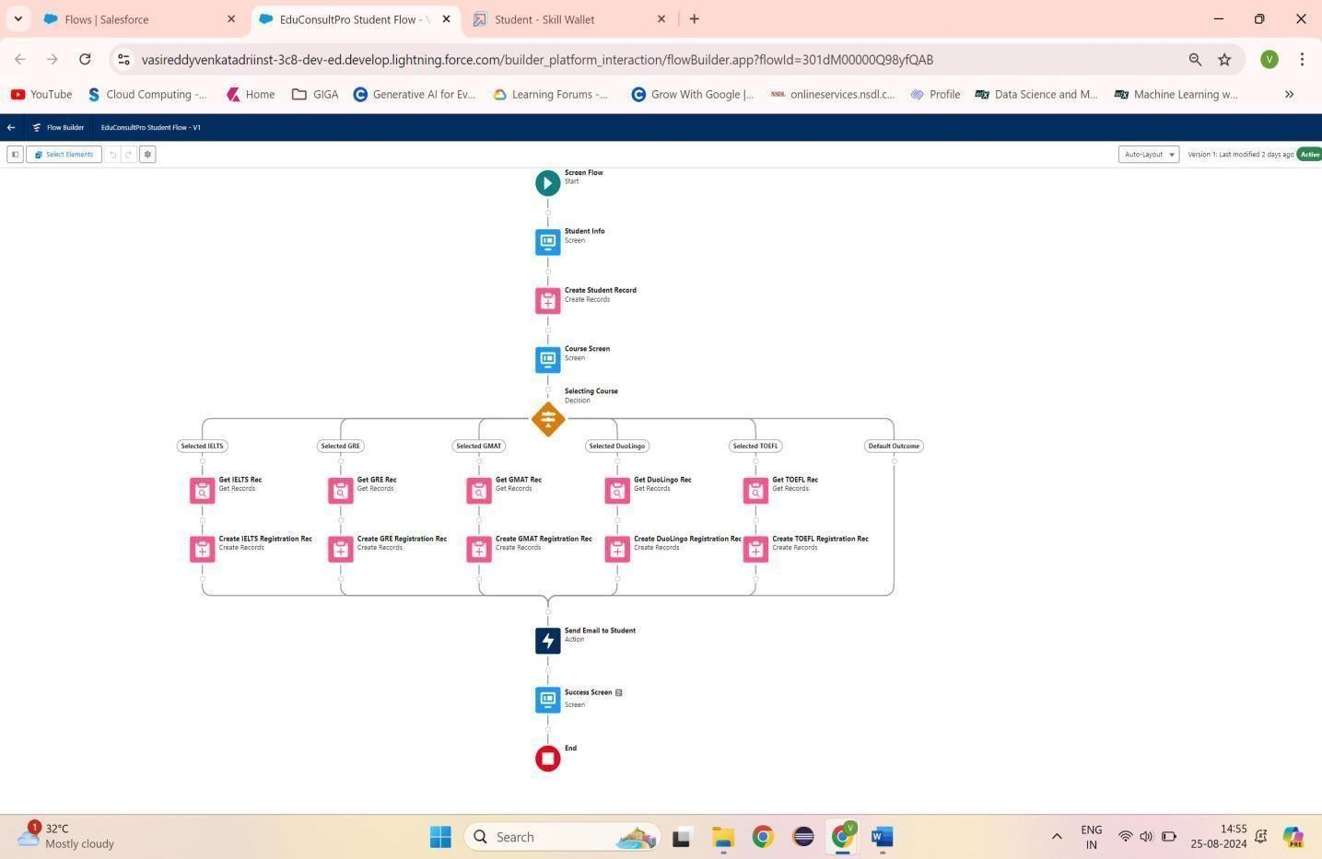**Fig1.3 EduConsultPro Lightning App**

**Fig1.4 EduConsultPro Student Flow**

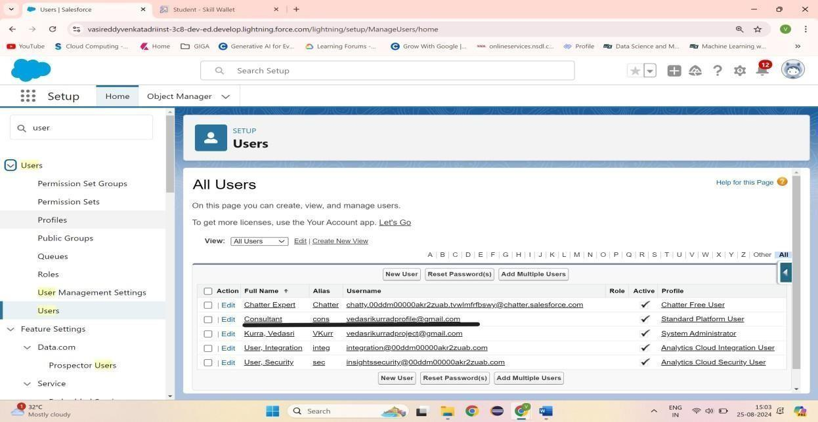

## Fig1.5 User

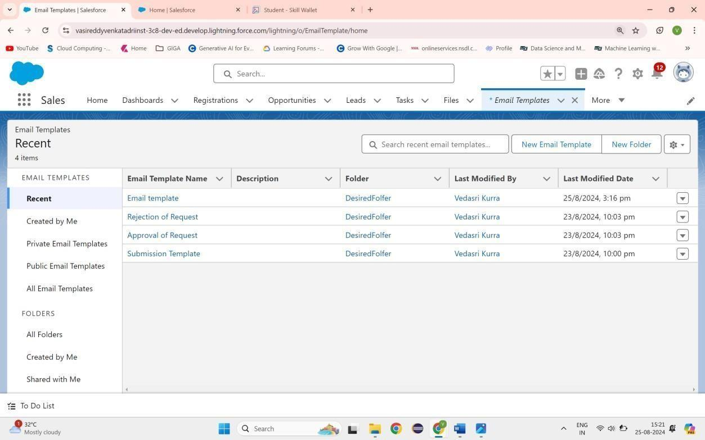

**Fig1.6 Email Template**

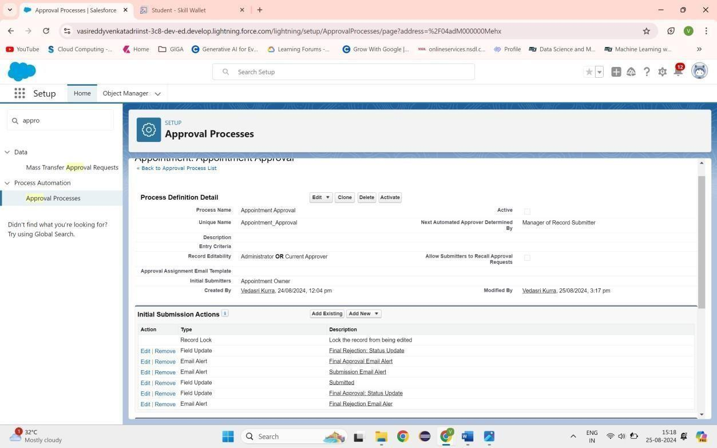

## Fig1.7 Approval Process

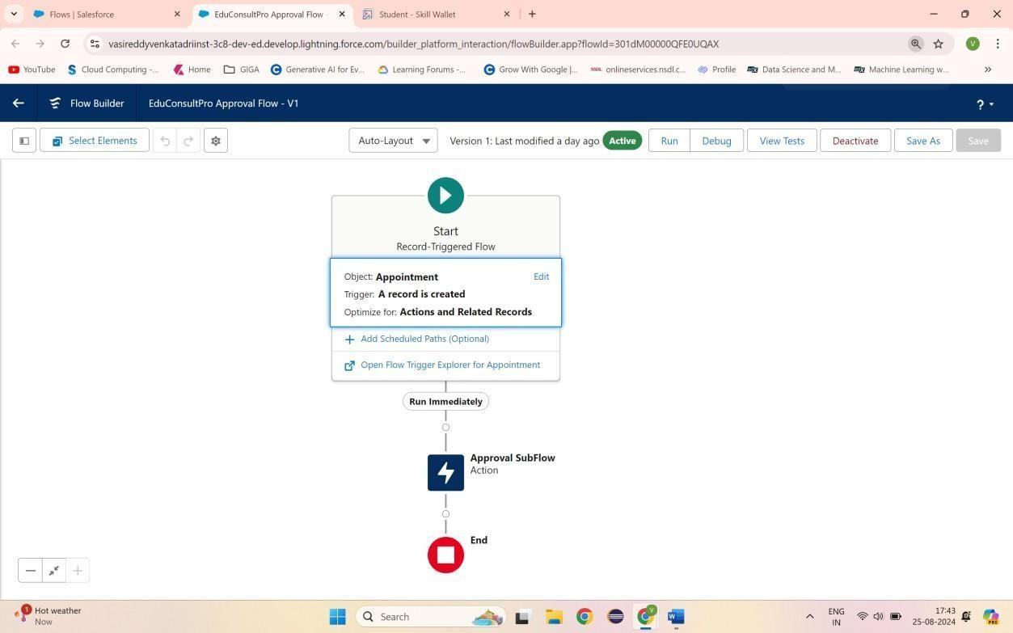

**Fig1.8 EduConsultPro Approval Flow**

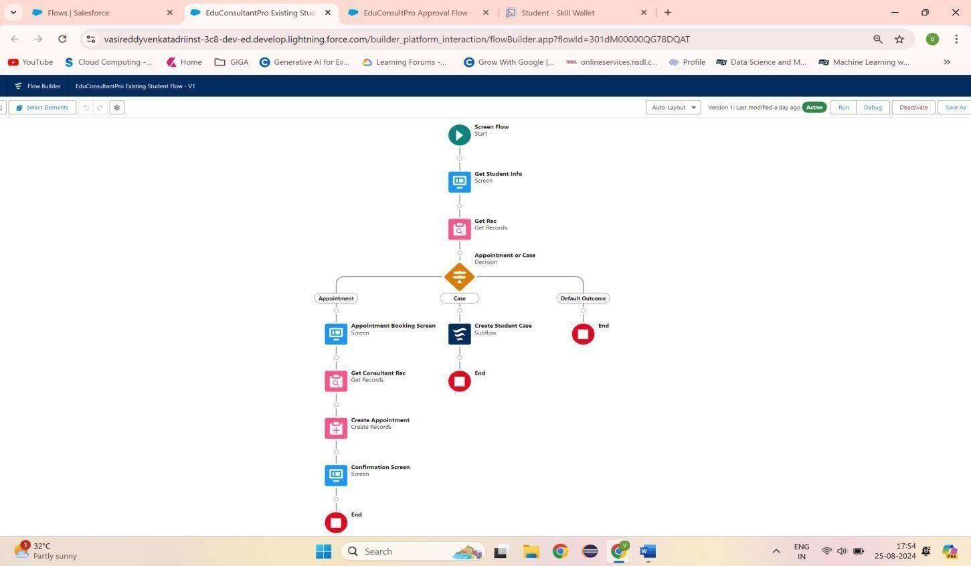**Fig1.9 EduConsultantPro Existing Student Flow**

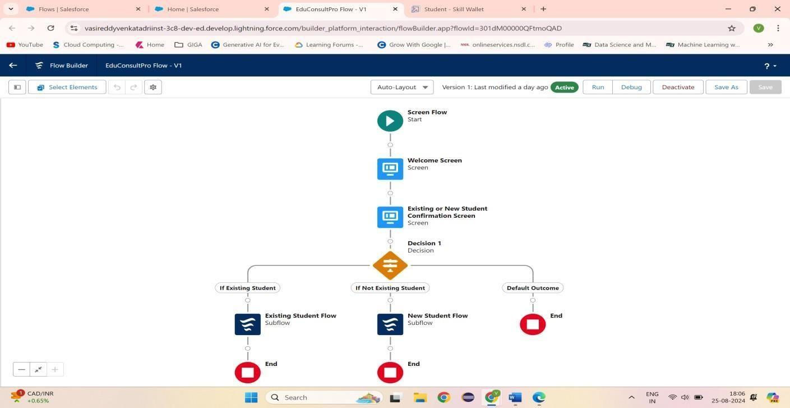

**Fig1.10 EduConsultPro Flow**

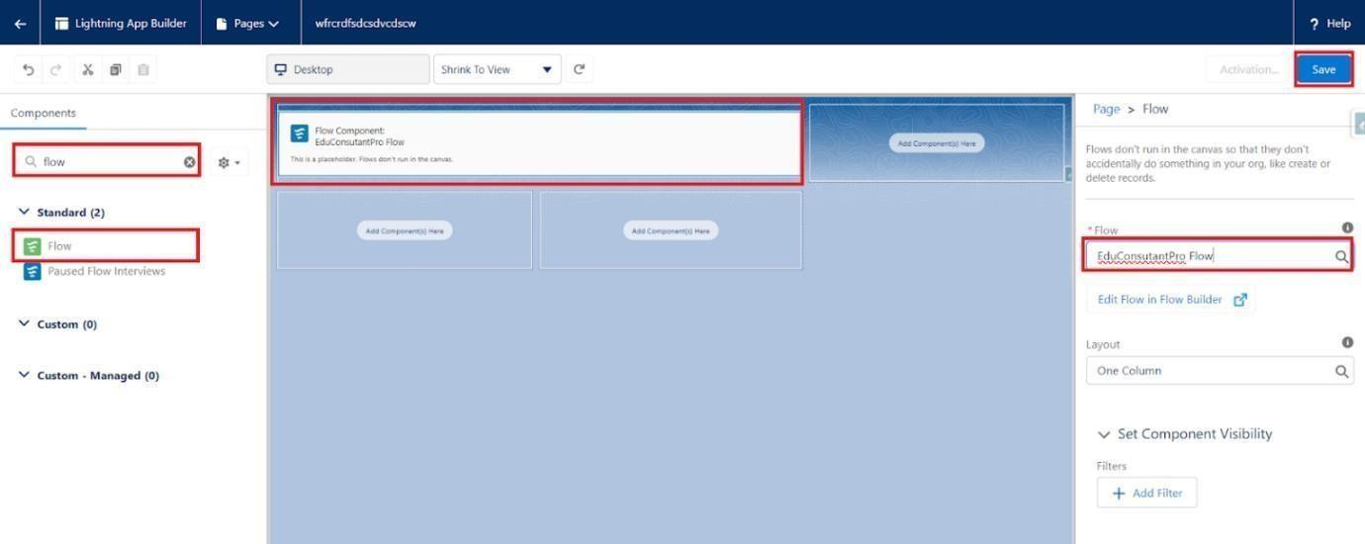

**Fig1.11 lightning app page**